SWAP PARTNER FEATURE FOR SINGLE & BULK REQUEST

STEP 1 (Single Request):

* Click swap partner submenu

* Enter required details

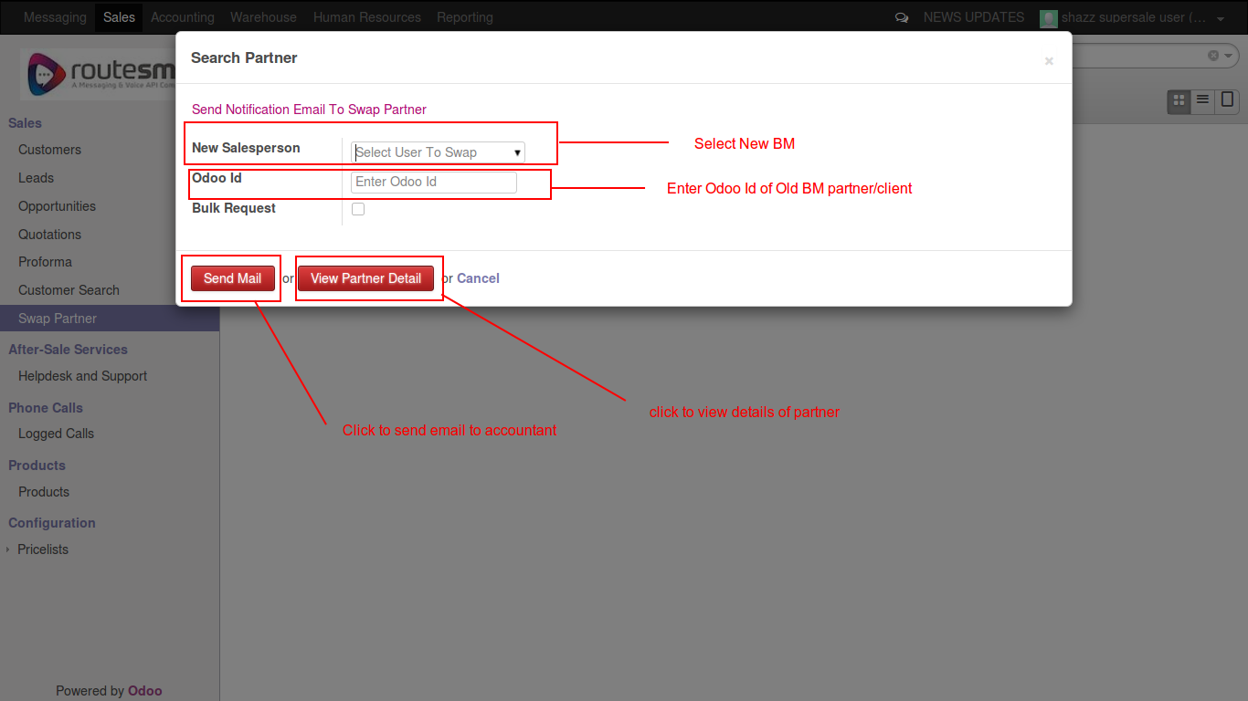

STEP 2 (Bulk request):

* Click on “bulk request” box

* Select Oid BM and New BM

* Click on “add item” to select Old BM partners

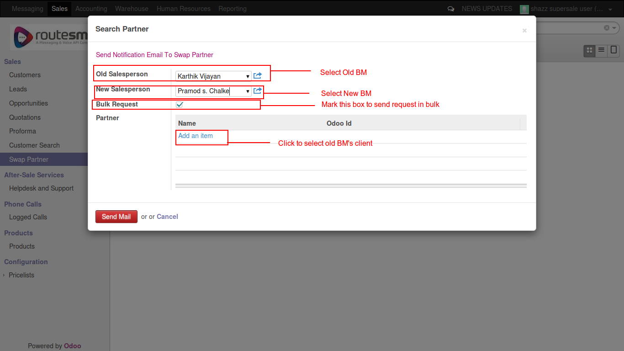

STEP 3:

* Select mulitple partners of Old BM

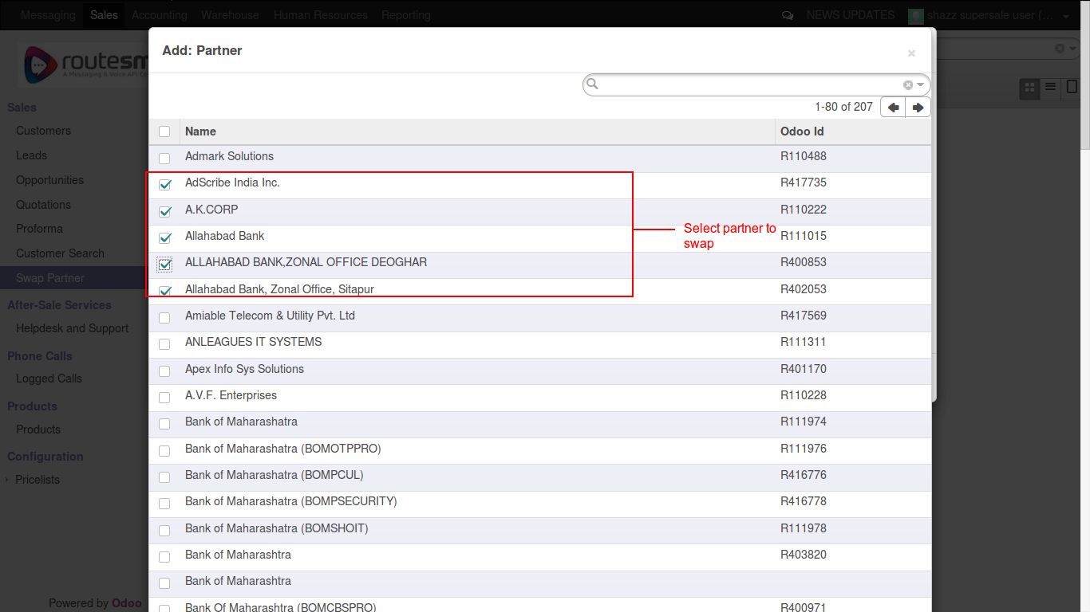

STEP 4:

* Scroll down & freeze the selection by clicking on “select” button

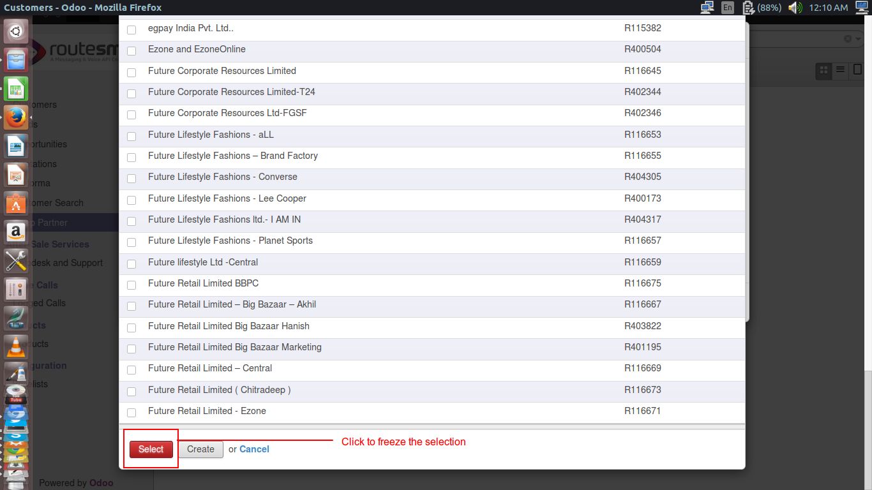

STEP 5:

* Selected partners are added

* Click “Send Mail” button to send bulk request via email to accountant

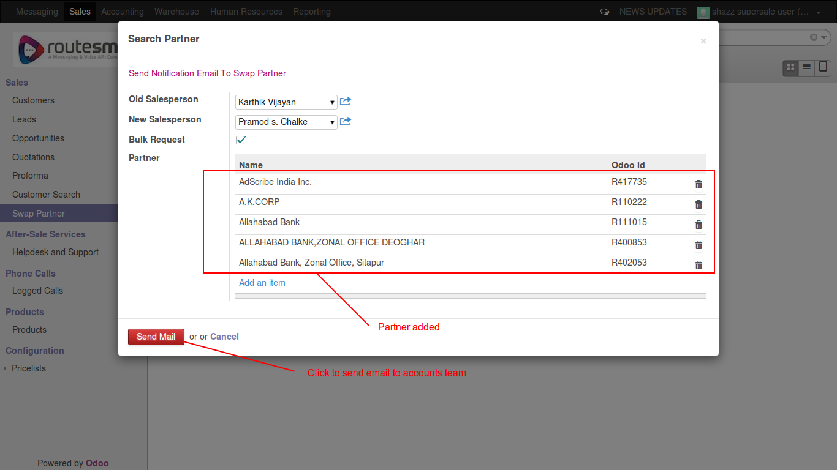

THANK YOU

CONTACT ME :

Email: shashank.verma@bistacloud.com
Skype: bista_shashank
Ext: 684

